**ITDA Class Test Sydney Twigg**

**Question 1**

1. Screenshot showing the creation of the database:

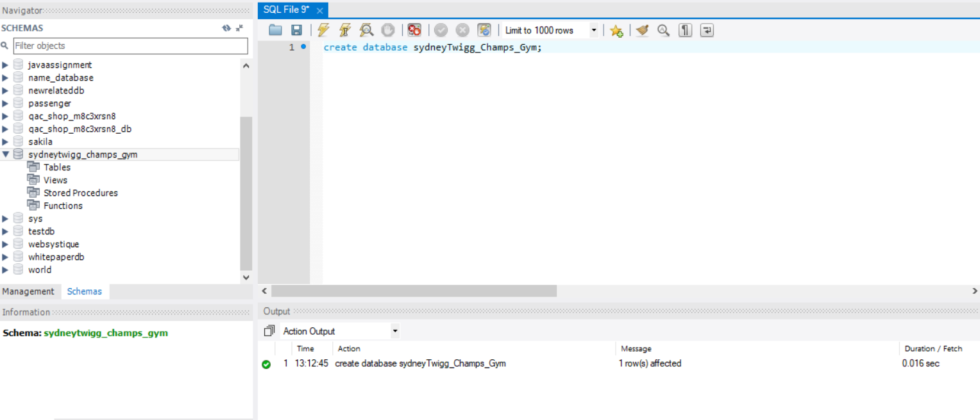

ii.

CREATE DATABASE sydneyTwigg_Champs_Gym;

**Question 2**

1. Screenshot showing the import of gym_members:

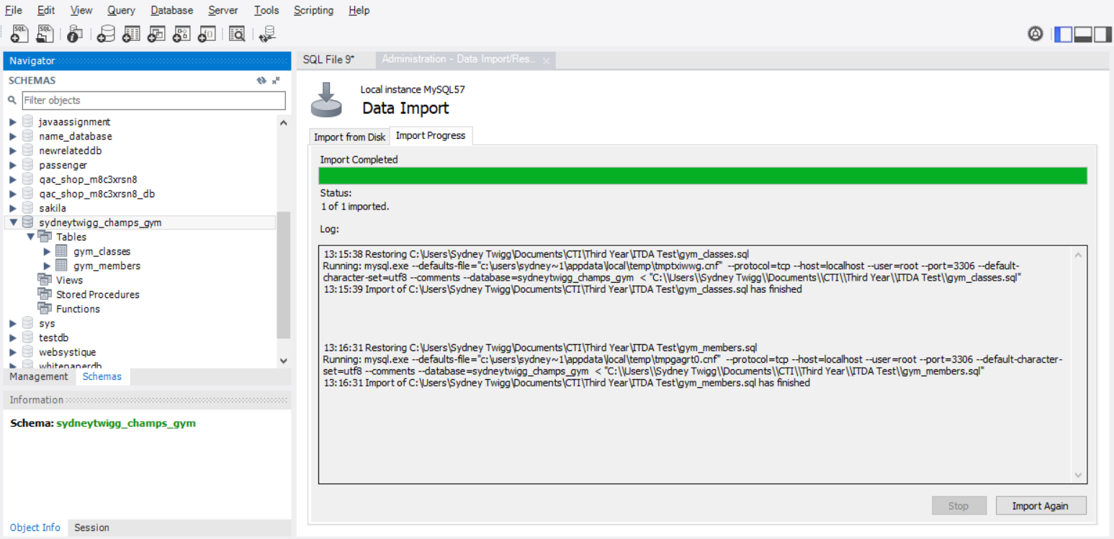

ii. Screenshot showing the import of gym_trainers: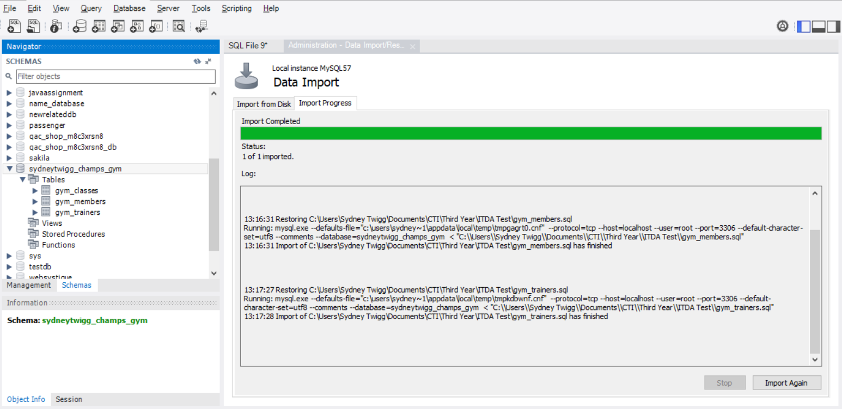

iii. Screenshot showing the import of gym_classes:

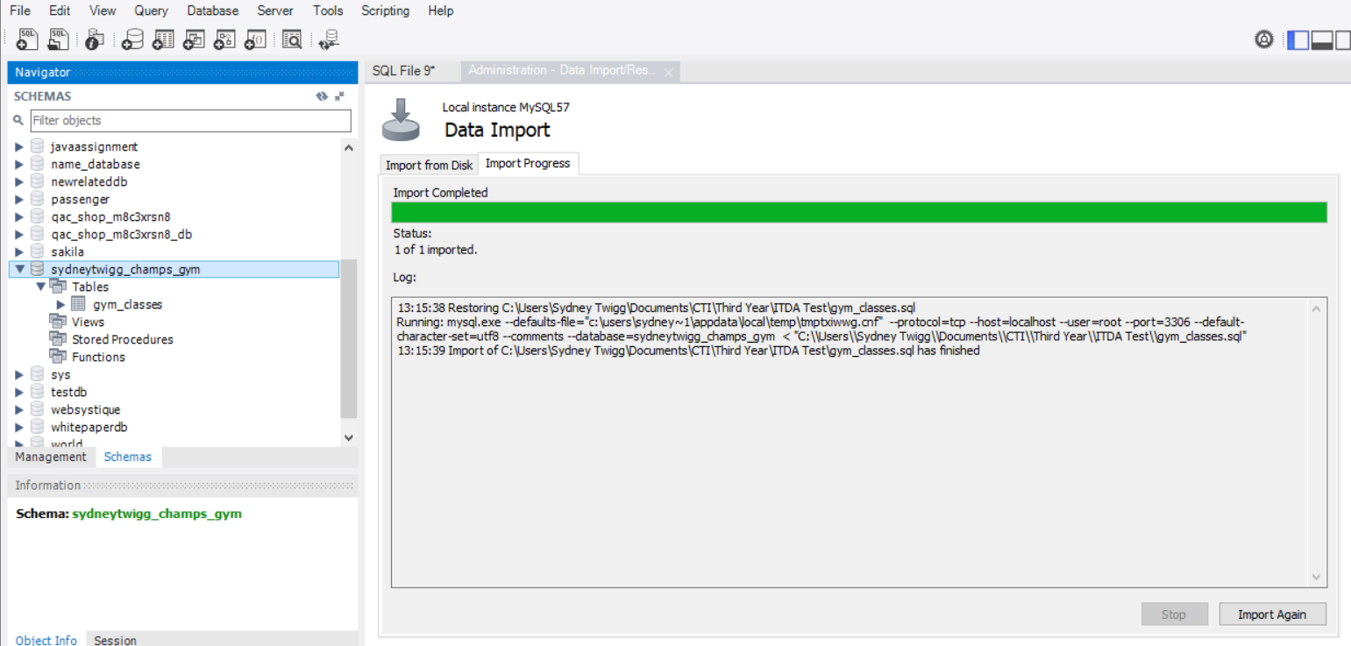

**Question 3**

Data in it’s original state:



DELETE FROM gym_members WHERE membership_no="10001";

DELETE FROM gym_members WHERE membership_no="10002";

INSERT INTO `sydneytwigg_champs_gym`.`gym_members`

(`Name`,`Surname`,`Membership_No`)

VALUES('Skipper', 'Hopper', '10001');

INSERT INTO `sydneytwigg_champs_gym`.`gym_members`

(`Name`,`Surname`,`Membership_No`)

VALUES('Jane', 'Beste', '10002');

Data after the above query was executed:



**Question 4**

i.

ALTER TABLE `sydneytwigg_champs_gym`.`gym_classes`

CHANGE COLUMN `classTime` `classTime` TIME NOT NULL ;

**Question 5**

i.

ALTER TABLE `sydneytwigg_champs_gym`.`gym_members`

ADD PRIMARY KEY (`Membership_No`);

ALTER TABLE `sydneytwigg_champs_gym`.`gym_members`

ADD CONSTRAINT UNIQUE(`Membership_No`);

ii.

ALTER TABLE `sydneytwigg_champs_gym`.`gym_trainers`

ADD PRIMARY KEY (`Trainer_No`);

ALTER TABLE `sydneytwigg_champs_gym`.`gym_trainers`

ADD CONSTRAINT UNIQUE(`Trainer_No`);

iii.

ALTER TABLE `sydneytwigg_champs_gym`.`gym_classes`

ADD PRIMARY KEY (`className`);

ALTER TABLE `sydneytwigg_champs_gym`.`gym_classes`

ADD CONSTRAINT UNIQUE(`className`);

iv.

The entity integrity rule used in the queries was entity integrity - insuring that all entities have primary keys that are not null and unique. Primary keys are used to identify a row in a table - thus cannot be null and cannot have the same value in more than one row, else the integrity of the table will be compromised. The columns chosen to be primary keys already had the constraint of being not null, thus only needed unique and primary key constraints to be added to them.

**Question 6**

i.

ALTER TABLE `sydneytwigg_champs_gym`.`gym_classes`

CHANGE COLUMN `classInstructor` `classInstructor` VARCHAR(255) NULL ;

ALTER TABLE `sydneytwigg_champs_gym`.`gym_classes`

ADD CONSTRAINT `trainer_FK`

FOREIGN KEY (`classInstructor`)

REFERENCES `sydneytwigg_champs_gym`.`gym_trainers` (`TrainerName`);

ii. Referential integrity refers to the foreign key of a table either matching the primary key of the table it references - or the value is null. Referential integrity ensures that all foreign keys and references have integrity and that there are not foreign keys matching to non-existing records within a table. In the above query the not null constraint was dropped on class instructor in order to fulfil referential integrity.